Forced deportation of Afghan Nationals from Iran is still continuing:
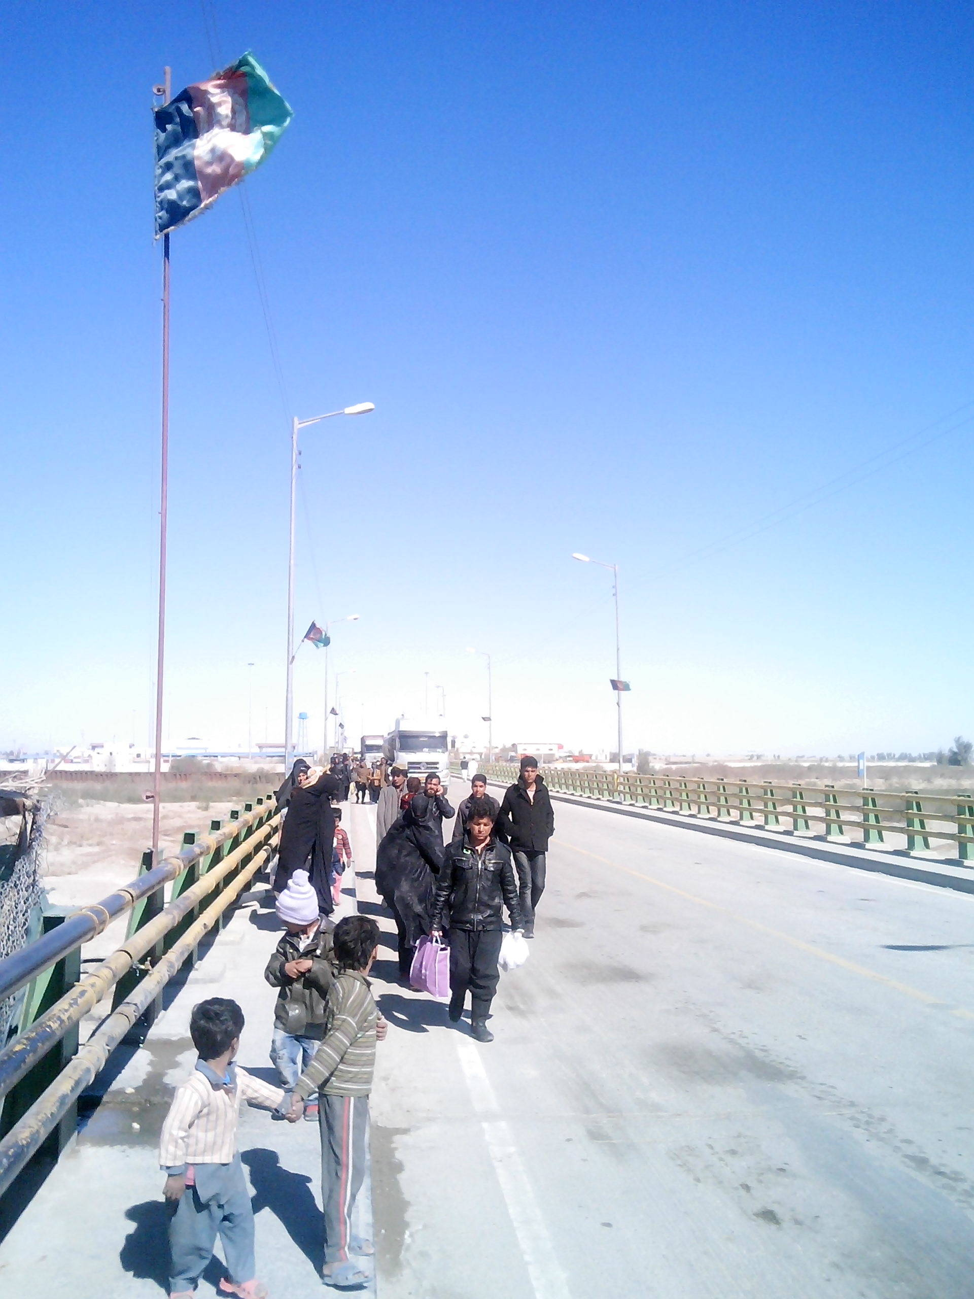Picture from Mr. FaridZaranj City Nimroz province.
Picture showing Afghans crossing Pool Abrisham from Iran towards Afghanistan .
The deportation takes place at two points inAfghanistan, one at Pool Abrisham (Abrisham bridge) in Zaranj city Nimroz province at the south west of Afghanistan and the second point is in Islam Qala the border point between Iran and Herat province at the west of the country. Here we cover only that deportation that takes place through Pool Abrisham only.
It has been noticed that most of those Afghans trying to escape to Iran through various illegal channels have been forced to dodo due to the ongoing poverty and unemployment in the country, although there are some other reasons as well, most of those individuals who try to go to Iran come from areas which is geographically surrounded with mountains and no hope for good employment has been noticed.
Starting 21 March -22 November 2014, 2031 families (1346 lead by male family member and the restlead by female family member ) consisting 8465 Afghans including 1118 childrenwere forced to cross the border from Iran to Afghanistan through Pool Abrisham.Almost all those deported had no legal documents to show that they could stay further in Iran, although there were hundreds of individuals who left behind their extended families since he or she was arrested by the Iranian authorities at some point and was no more allowed to join the familythat was still in Iran and were illegally living there in order to get job and feed their families.At the same period 39581 individuals all single male Afghans including 2793 children were deported to Afghanistan through the same route.Also 643 vulnerable individuals(almost all male) including 205childrenwere forced to deport, although they were the victims who were either beaten, tortured in the Iranian custody,or injured by the Iranian police when trying to escape on the way to Iran, or even suffered injuries during various traffic incidentswhen trying to escape from the arrest of the Iranian police. Also some of those individuals were either sick and had no relative family or friends to take care of their health and alternatively preferredto surrender them self to the police in order to be arrested and deported back to Afghanistan through the nearest border where they were not supposed to pay for transportation charges . Most of those 643 individuals were given temporary shelter and food by IOM at a Camp inside the Afghan border and many of them were financially supported with transportation charges to their place of origin. At the same period it has been recorded that at least 42780 Afghans including 4014 children were illegally trafficked to Iran through various deserted border points between Iran and Afghans.( some others says that around 500-1000 individuals are flying to Iran on daily bases, something that has not been confirmed officially) Some of them were trafficked through the borders points between Iran and Kang district in Nimroz province and some others through KhubGah area that has been situated between Zaranjcity and ChaharBorjak district in Nimroz province.But a majority of them were trafficked first to ChaharBorjak district In Nimroz followed bygoing to Dak area that is around 60 Kilometers away from the district center of ChaharBorjak and is right on the border between Afghanistan and Pakistan, later they have been delivered to the travel agents ( human traffickers) who then takethe refugees to Mashkel and Marjawa area in Pakistan territory that is around 100 Kilometers way from Dak, and those two areas has been situated very close to the Pakistan Iran border. After having a rest of two –three daysthe refugees have been taken than to the following areas one after another.First to the Iranian town near the border namedIran Shar followed byKhush then to Zahedan and at last to Kerman where they have been normally spread to other parts of the country.
Notes:
Author : Neamatullah Neamat Independent Researcher.
Information gathered from Human Rights Activists, Civil Societies, victims, witnesses and Local elders on the ground.
Figures Received from Multiple sources including Human Rights Activists.
Picture from Mr. FaridZaranj City Nimroz province.

