Forced deportation of Afghan Nationals from Iran is still continuing 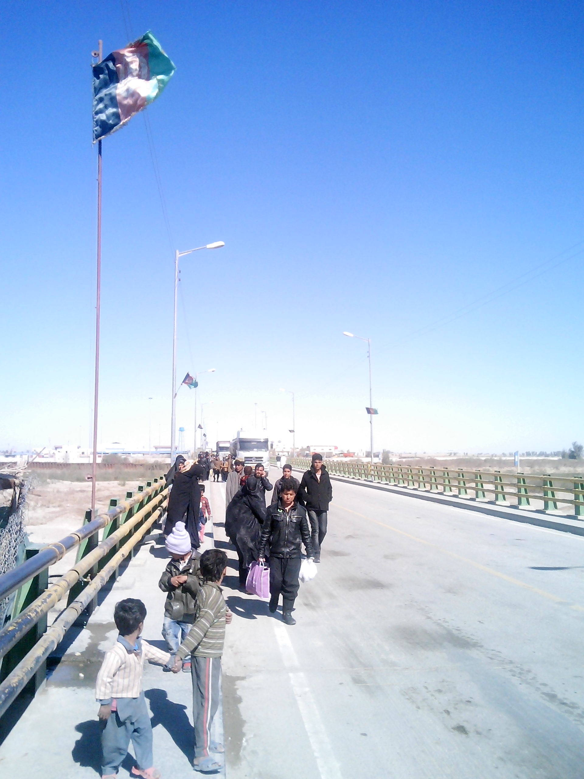
Picture from Mr. FaridZaranj City Nimroz province.
Picture showing Afghans crossing Pool Abrisham from Iran towards Afghanistan .
The deportation takes place at two points in Afghanistan, one at Pool Abrisham (Abrisham bridge) in Zaranj city Nimroz province at the south west of Afghanistan and the second point is in Islam Qala the border point between Iran and Herat province at the west of the country. Here we cover the deportation that takes place through Pool Abrisham only.
It has been noticed that most of those Afghans trying to escape to Iran through various illegal channels have been forced to do so due to the ongoing poverty and unemployment in the country, although there are some other reasons as well.Most of those individuals who try to go to Iran are coming from areas which is geographically surrounded with mountains in Afghanistan, where no hope for good employment expected.
Starting 21 March -22 November 2014, 2031 families (1346 lead by male family member and the rest lead by female family member ) consisting 8465 Afghans including 1118 children were forced to cross the border from Iran to Afghanistan through Pool Abrisham. Almost all those deported had no legal documents to show that they could stay further in Iran. Hundreds of individuals has left behind their extended families since he or she was arrested by the Iranian authorities at some point and was no more allowed to join the family who was still in Iran and were illegally living there in order to get job and feed their families. At the same period 39581 individuals all single male Afghans including 2793 children were deported to Afghanistan through the same route. Also 643 vulnerable individuals (almost all male) including 205 children were forced to deport. This category individuals were the victims who were subjected to various types of miss behavior including torture and beating by the authorities in the Iranian detention facilities. Some of those individuals got injured by the Iranian police during the course of migration to Iran through illegal routes. Some of them suffered injuries during various traffic incidents inside Iran. (Means when the individuals were trying to escape from the arrest of the Iranian police). Also some of those individuals were either sick and had no relative family or friends to take care of their health, alternatively the individuals preferred to surrender themselves to the police in order to be arrested and deported back to Afghanistan through the nearest border where they were not supposed to pay for transportation charges or go back through the dangerous ways that they came with while coming from Afghanistan. Considering the vulnerability of most of those 643 individuals they were given temporary shelter and food by IOM at a Camp inside the Afghan border, just after they stepped into the Afghan border. Most of the vulnerable individuals were financially supported with transportation charges up to their place of origin inside the country. Department of MRRD has confirmed that between 5-10 dead bodies of Afghan nationals have been counted crossing Afghanistan from various parts of Iran through pool Abrisham.Most of those bodies belong to Afghans who were either killed during the course of their journey to Iran when shot killed by border police, criminals or even killed because of traffic incidents or even injured during the course of their trip and later died because of serious injuries. The number also includes victims who has been killed during various traffic incidents that take place in Iran. Some of those bodies also includes victims who were sentenced to death in Iran and those who has meet their sentence followed by transferring their bodies to their home country. But specific number of such type of bodies have not been obtained.Who has been injured during various trafficking incidents in Iran or during their travel to Iran,the number also includes victims who were indiscriminately shot killed by the Iranian soldiers during the time of the arrival of the victims to Iranian territory.
Brief information on how Afghans have been trafficked to Iran.

It has been recorded that Starting 21 March -22 November 2014 at least 42780 Afghans including 4014 children were illegally trafficked to Iran through various deserted border points between Iran and Afghans and most of them were adult male.( some other reports says that around 500-1000 individuals are flying to Iran on daily bases, but that information has not been confirmed officially). Some of them were trafficked through the borders points between Iran and Kang district in Nimroz province and some others through KhubGah area that has been situated between Zaranj city and ChaharBorjak district in Nimroz province. But a majority of them were trafficked first to ChaharBorjak district In Nimrozprovince followed by going to Dak area that is around 60 Kilometers away from the district center of ChaharBorjak and is right on the border between Afghanistan and Pakistan.Later they have been delivered to the travel agents (human traffickers) who then take the refugees to Mashkel and Marjawa area in Pakistan territory that is around 100 Kilometers way from Dak, and those two areas has been situated very close to the Pakistan Iran border. After having a break of two –three days the refugees have been transferred to the following areas one after another. First to the Iranian town near the border named Iran Shar followed by Khush then to Zahedan and at last to Kerman where they have been normally spread to other parts of the country.
That route is one of the busiest Human Trafficking route for Afghan refugees trying to illegally enter to Iran. It has been claimed by a number of the deported Afghans who were trafficked to Iran by the Human Traffickers that they were charged 1-3 million Tomans (Iranian Currency) that makes roughly 50000-60000 Afghanis or US $ 1000,this amount of money covers transportation charges, meals and accommodation during the two-five days travel from Daktown till Kerman as a last stop inside the Iranian territory . Many victims or deportees have told Human Rights activists that they witnessed a number of passengers were shot killed by the Iranian border police on their way during the course of the trafficking,( no one could help them or pick the dead body up, unless a close relative was travelling with them)although some of the traffickers are kind and they transfer the bodies and find a way to inform the family of the victim on the status of their loved one. Some others have been killed or injured as a result of traffic incidents when their vehicles rolled out due the worse condition of those ways that the human traffickers use since the routes they use are the worst, or that the drivers were so careless or driving speedy although no paved Road and other necessary facilities available throughout the trip. The refugees also claims that some victims lost their lives due to the sickness they were suffering from and at last some others were taken into hostage by armed robbers for ransom, but unfortunately most of the dead bodies were never taken back to their families since no one could help them due to the threat of arrest by the Iranian authorities. Some of those bodies were buried by people passing from the area, but many others were simply eaten by wolves and birds. Most of those dead bodies have gone missing and their family never got informed about the death of their loved ones unless informed by someone they knew travelling with the victim.

It has been noticed that the waves of illegal refugees trying to fly to Iran is up and down and it also belong to the warm and cold weather in Iran and Afghanistan. Most of those refugees come from the northern and central provinces of Afghanistan. when it is cold in some areas in Afghanistanthey prefer to go to Iran in order to get jobs and earn money for feeding their extended families and some of them are returning back when the weather get warmer in their areas. The same goes for the warm and cold seasons In Iran when it is warm and as far they could get daily labor there they are happy and try to stay there, but when it is cold and they think they would not find work for the next few months than they prefer to return home for finding any possible work and stay with their families.
Testimony from a victimwho was forced to cross Afghanistan from Iran through Pool Abrsham in November 2014,Interviewed in Zaranj city in November 2014.
’’I was ready to diefor feeding my family since it was the only option left at my hand and that is why Iaccepted such a high risk and started travelling to Iran through the illegal channel, although I knew about all the possible threats throughout the most dangerous journey’’.
My name is Mohammad Karim Haidery and am from Kara Bagh district in Ghazni province. I paid 1300000 thomans to an agent who carried me to Iran a year and half ago. I had no friend or relative in Iran and it was my first time to travel to Iran. I was dreaming for getting a good job in Iran and was planning to call my family to Iran once I settle and get the necessary amount of money. I travelled 27 days starting the day I left behind my family and the day I arrived in Kermanwhere I was have to call my family and assure them that I have arrived safely, I also told them that they should give the rest of the money to the agent in Afghanistan.(normally half of the money is given to the agents in advance and the rest would be given once the person arrive to the location specified).I suffered so many problems once we started to depart from ChaharBorjak. We were supposed to reach to our destination during 10 days but we were struck in Merjawa and were have to wait for the agent to bring another group of immigrants who were supposed to travel with us.I did not see any person killed but meet with people who told me that they have seen dead bodies of immigrants. (Mr.Rezawho was from Bamayan province told me in Kerman that one of their colleague from their group was shot injured by the Iranian police when the drivers did not stop when ordered by the border police when they were crossing the border near to a check post in Iran Shahar area. The agent did not stop and carried the injured victim to a place where he did not know about the name)Mr. Haidery added that they were given very little food and water during the course of the travel,and they had no other option to buy food of their choice since no market available on the way they used.Even where markets available they were not allowed to show up in local markets’’although most of the travel was on the deserts and mountains.Mr.Haidery added that there was no health care unless one critically sick. Most of the time we were travelling during the night in order avoid the attention of the police who might use their binoculars from their check post when watching the routes.
Mr. Haidery added thatI was told by a friend that so many Afghans still live in various parts of Iran without having any job and they have been struck there for years since they could not afford the cost for returning home.
Mr.Haidery adds that thousands of Afghans have been addicted to drugs and work for people who could simply feed them twice a day. Thousands of Afghans have been put in Jails having criminal or drugs related cases. Tens of Afghans have been sentenced to death and most of them have already met their sentence. Hundreds of Afghan refugees have been kept in jails since years without letting their families know about their status. Their families think their loved ones have been struck for their jobs and hope they will return with a good bunch of income. One of my relative named Reza Mohammadi have gone to Iran several years before and has never returned yet. No one knows about his where about. Two years before his family was informed by a deportee that Mr.Mohammadi was surviving in a Jail in Iran since the last five years and have been sentenced in a drug related case, but no exact address of the jail provided to the family since the person who brought the information says that he has heard about the case and does not have the address now since he is not familiar in Iran. The economic situation of the family of the victim is so vulnerable and that is what that does not allow the family to go to Iran and find more about Reza. The family members travel for hours and days in order to go and meet a recent deportee arrived in their area,whom they expect to hear about Reza or incase the deportee has got any information about Reza,but so far they have not been able to get first-hand information about Reza ,address of his Jail or any other information that could help the family tofollow the case for finding their loved one.
On 14 November 2014 a witness told the author that he saw three adult male who had several minor injuries on their face and bodies and were claiming that they were badly beaten by the Iranian police during the course of their deportation from Zahedan to Pool Abrisham when kept in the Iraniandetention for three months and later deported to Afghanistan I saw their injuries said the witness who meet the victims in PoolAbrisham early November 2014.The victim adds that he was told by all the three deportees that they do not have enough money to cover charges for their health care and they think they might not be able to see their family and friends till their wounds disappear. ”They would be ashamed for telling their stories of beating and torture”. Our friends never know what we have suffered while in Iran, all that they think about us is that we would have had good income during our stay in Iran said one of the deported victims named Mohammad Karim
Why Afghans still accept risk for going to Iran and take illegal shelter in there.
The forced deportation of Afghan nationals illegally crossing Iran started in 2002 soon after the new government leaded by President Hamid Karzai took power in the country. The waves of the deported families is up and down but it has never stopped since its start. The deportation takes place at two different border points between Afghanistan and Iran .One in IslamQala that is part of Herat province at the west of the country. And the second deportation point is Pool Abrishamin Zaranj city the capital of Nimroz province at the south west of the country. The deported families and individual persons have been counted on daily bases by the department of the Ministry of Refugees and Returnees (MRRD),Afghanistan Independent Human Rights Commission (AIHRC ) International Organization of Migration ( IOM) and other NGOs working on that era .
The AIHRC, and MRRD estimates that between 60-100 families (consisting 4-8 staff members each) have been deported every week through Pool Abrisham inZaranj although majority of the deported families consists children and women, But the single deported Afghans are mainly adult male, although some underage boys accompany them.
The deportation has not only targeted those Afghans ‘’who illegally cross Iran borders’’ butthousands of Afghans legally staying in Iran have been forced to leave the country once they have verbal or working disputes with Iranian national. It should also be taken intoconsiderationthat hundreds of children have been separated from their families and forced to deport once arrested at some point. Victimclaims that they were physically tortured, beaten and even looted on the way to the border where the deportation was taking place.
Brief profile of Nimroz province that hosts the newly deported families and individuals on daily bases.
Nimroz province lies in the south west corner of Afghanistan. It is bordered by Helmand to the east, Farah to the north, the Iranian province of Sistan and Baluchistan to the west and the Pakistani province of Baluchistan to the south. Nimroz has a 223 kilometre border with Iran and a 224 kilometre border with Pakistan. The provincial capital, Zaranj, is in the west of the province, directly on the border with Iran. Nimroz has six districts: Khashrod (Ghorghori), Delaram, Kang, Chakhansur, Chaharburjak and Zaranj.

Much of Nimroz is on the desert, The whole of the province can be described as being desert with descriptive area names such as “the desert of death”, although there are two principal rivers running through the province, along which much of the rural population is settled. The River Khashrod enters Nimroz province at Delaram, where it is an open flowing river and eventually disappears into the desert some 80 km to the south west, at Khashrod. The River Helmand enters the province from the east and empties into the Hamun-i Helmand, a seasonal lake between Iran and Afghanistan.

Temperatures in Nimroz can reach 50 degrees Celsius during the summer months. The province is prone to fierce sand storms, which can last for days at a time.

There is a new, asphalt road running for 210 km through the province from Zaranj to Delaram, where the road meets the national ring road, Highway 1. The only other asphalt roads are in Zaranj.

In general, Zaranj is very Iranian in outlook, with many people less conservative than in other parts of the region. This is particularly noticeable amongst the women, who rarely wear the traditional burka, preferring instead to wear Iranian-style clothing.
Economy
While there is some farming, the economy of Nimroz is largely based on trade, both licit and illicit. Most trade is across the border with Iran, with two official border crossings, at Zaranj and Telayi in Kang district. There is a huge amount of smuggling of a variety of goods. It is not known how much legitimate customs revenue is taken at the border and how it is distributed, although it is believed there is a lot of extortion by officials on the border as part of an organised network.
Nimroz Province is very poor in terms of agriculture with only 10% of the land being cultivated. Agriculture is mainly based on crops; wheat, maize, melons, water melons and little orchard. Nimroz used to be very rich in terms of livestock in the past: oxen for traction, cows for breeding and milk, sheep, goats and camels. Around 85% of locals in Nimruz live in rural areas while 15% live in urban areas. Still the families keep animals, but lack of sufficient fodder and veterinary facilities constitute major problems. Families keeping animals, smuggle them to Iran for selling. Also, oxen and buffaloes coming from Pakistan are being sold via Nimroz to Iran.
When did the forced immigration started in Afghanistan and why.http://education.nationalgeographic.com/media/file/afghan_MIG.pdf
On 25 Dec 1979 the army of the Union of the Soviet Socialist Republics ( USSR) arrived at Afghanistan. Soviet leaders said the Government of Afghanistan invited them to assist in a crisis. Most of the world leaders recognized the massive troop movement as an invasion. Afghanistan recently undergone a revolution that was supported by the Soviet Union while the Mujahedeen militias were supported by the United States. The invasion and occupation of the Soviet Union lasted from 1979-1988.

The waves of migration started along with heavy conflicts soon after the invasion. Also internal displacement reached to a higher stage.
An estimation says that more than six million Afghans fled outside the country and were settled in various parts of the world including the EU, Unites States, various countries in Asia and Africa with a vast majority who crossed the border to Pakistan followed by Iran. Throughout this period, neighboring countries such as Pakistan and to Iran, hosted the refugees. Pakistan welcomed the refugees while some Western nations, showing a willingness to share the burden to support the refugees by giving generously to the aid agencies involved. Although the political tensions between Iran and Western nations did not facilitate similar types of Western support to Afghans in Iran, refugees were ‘welcomed’ in the sense that they were allowed to work and more or less ‘integrated’ into society. But they were provided little in the way of formal protection and assistance.

http://www.forcedmigration.org/research-resources/expert-guides/afghanistan/needs-and-responses
The same time, Iran was engaged in a programme of forced return which saw the end of temporary protection status for many Afghans who had sought refuge there. But like Pakistan, Iran had grown tired of hosting the refugees and seized every opportunity to both stop the entry of Afghans (by closing its borders on the basis of concerns for national security caused by a breakdown in relations between the two countries), and to deport many who had remained in Iran for extended periods of time.

The Migration did not stop when the Russians went out of the country in 1988, although some refugees returned with most of them from Pakistan and Iran. At that time most of the ex-government staff members preferred to run out of the country since they did not prefer staying any more due to the threat of any possible target against them while considering their ex-employment by a government that was supported by the Soviet Union.
Although millions of Afghans returned home when the Soviet Union left Afghanistan, but they did not meet their expectations of having a peaceful and relaxed life, good employment and a peaceful country.
Internal conflicts explored across the country that continued almost for two decades and took lives of hundreds of thousands of Afghans and unfortunately part of that series is still continuing and every day tens of Afghans lose their lives due to the ongoing conflicts and leave behind their orphanages, widows, families, friends and loved ones. The new government was established 13 years before. But it did not stop the forced migration the way it was expected but even continued on daily bases considering the threat of the ongoing clashes between AGEs and PGF.
Local source:
Many others leave the country for seeking better economies somewhere out of their country. Others leave the country due to the threat of the ongoing clashes for their life and the lives of their families.Also some people run away due to the threat of any possible threat to their life considering their personal enmities that they have committed during the last three decades war in the country.
Many others fly due to the threat of any possible prosecution for the crimes they have committed in the past 3 decades war.
But after all that the forced deportation by states mainly by the government of Iran continues and tens of families. Most of the deported migrants have told Human Rights Activists that they were physically and verbally abused by the Iranian police during the course of the deportation with many others who has claimed that they were looted by the police and the cash they have had in their pocket were stolen one way or another, and the good reason the police had against them was that they were illegally living in that country.
What happens to those returning their country or forced to return to their country.http://www.operationspaix.net/DATA/DOCUMENT/4051~v~Internal_Displacement_in_Afghanistan.pdf
Due to the intensity of the conflict and often entrenched positions of the warring parties, displacement is becoming increasingly prolonged. Land mines/ UXOs (Unexploded Ordinance) and the destruction of crops, fields, homes, and properties during fighting have a direct impact on the ability of displaced populations to consider voluntary return to places of origin and to resume livelihoods. Deterioration of the protection situation in places of displacement can be expected in the medium term, especially due to severe winters in the north and some western and Central provinces a well as a number of provinces in the north east and at the south of the country, also summers in the south, west and the east.The absence of critical services/facilities available in places of displacement, and the lack of livelihoods. The likelihood of secondary displacement within and outside the region is high. Vulnerable IDPs face heightened risks in the absence of an expedited return to normalcy. Instances of displacement from the South to the East and Central regions are cases in point. It has not been possible to consistently track secondary displacements which usually occur in small numbers (individuals, families or small groups). In this changing context, mid-term needs assessments by humanitarian actors become more relevant, especially for responses to those with heightened vulnerability.

Uprooted from their homes, forced Migrants face an urgent need for shelter. Predominantly, recent arrived families in rural settings seek refuge with host families. On the other hand, in urban areas the families who can afford do so, rent houses, often jointly with others. For the poorest families, renting accommodation leads to further impoverishment due to the absence of regular income.
Complexity of Finding Durable Solutionshttp://theconsul.org/?p=447
Perhaps the situation for refugees from Afghanistan within the country is often overlooked because of the complexity of finding durable solutions to the problem. Global responses to forced migration in Afghanistan can be at various levels: working towards the prevention of the conflict that displaced so many citizens; providing immediate assistance to these displaced people; providing skill training for forced migrants; repatriating them; rehabilitating them in new environments; encouraging integration in either the homeland or a new region. Most important players in this issue simply chose the policy that best suits them in terms of self-interest at a given time and pursue it. This leads to the lack of a cohesive and combined approach which is what Afghanistan needs to solve its problem of forced migrants.
End Notes,
Author: Neamatullah Neamat Independent Researcher.
Figures and information received from:

- Human Rights Activists
- Civil Societies.
- Witnesses.
- Department of Refugees and Repatriation.
- Local residents of Pool Abrisham area and Zaranj city.
- Victims and deportees.
- http://www.forcedmigration.org/research-resources/expert-guides/afghanistan/needs-and-responses
- http://education.nationalgeographic.com/media/file/afghan_MIG.pdf
- http://theconsul.org/?p=447
- http://www.operationspaix.net/DATA/DOCUMENT/4051~v~Internal_Displacement_in_Afghanistan.pdf

