**On the edge: Women- Life and Confinement**

Sucharita Sengupta

[Draft Paper]

“Imagine there’s no countries it isn’t hard to do, nothing to kill or die for and no religion too, imagine all the people living life in peace” [A song by John Lenon]

Imagining a world without boundaries is impossible especially when marking and securitizing boundaries constitute the heart of international relations and politics. People in the peripheries or migrants are ignored mostly but the undeniable truth is that they are important to understand the core of nation formation in South Asia[1]. The study of nation no longer assumes a crucial place of significance, instead, ‘governing the mobile’ and messy flow of population has become the centre of our political understanding[2]. “This is linked with a broader context, i.e. the processes of globalisation. It is now increasingly being argued that capitalism and the processes of globalisation will give rise to new global geographies and increase all manner of links (cultural, political, economic, informational) across boundaries”[3]. Although transnational population flow/migration/forced migrations as categories are distinct but the difference in their meaning often gets blurred in practice. They can neither be branded as fixed or watertight categories nor situations of exception or banality specifically in the context of South Asia. To stress on the bit of exception following Agamben would therefore mean ignoring concrete colonial and post-colonial conditions in countries like India where conditions of exception are integral to the socio-political history of this region[4]. At this juncture a crucial question could be invoked in studying the cross border migration between India and Bangladesh which is can migration in this specific historical and geographical context is ever ‘free’? There is always some kind of a force either in form of ethnic violence, domestic tensions or sheer economic compulsions that propel continuous movement of people across the Bengal Borderland[5]. Thus drawing from a point made by B.S.Chimni at a Conference in Cairo in 2008 and expanded further by Ranabir Samaddar[6] the point being made is that migration is almost never ‘voluntary’ or ‘free’ and the margin between people willing to cross the border and forced to do so often gets annihilated. This paper aims to unravel the vulnerability of women migrants across the Bengal-Bangladesh border who knowingly or unknowingly, illegally, have crossed the demarcation line between the two territories and have landed in many prisons in this side of the border. Mostly economic migrants, these women hail from a very low economic background with absence of any formal education.

Prison as a space in this paper is used as a prism through which I try to understand the porous, precarious, mobile and dynamic nature of a borderland and the flows- both human and goods across it specifically in context of the West Bengal-Bangladesh border. Drawn arbitrarily on a paper, this particular borderland has never been passive since its birth; rather it has a very vibrant space along with a strong parallel economy. In many ways the border has encroached upon the main land. This paper thus proposes to look at the precariousness of the borderland and civilian lives shaped by it through a frigid space. Prisons or correctional homes in this research talk about women who do not necessarily live in the Bengal borderland but whose lives are none the less shaped by it. The more the border has been secured, the more insecure their lives have become.

This paper studies four Correctional Homes in this context- Balurghat District Correctional Home (South Dinajpur District), Behrampur Central Correctional Home (Murshidabad District), Dumdum Central Correctional Home (Kolkata) and Alipore Women Correctional Home (Kolkata). The purpose of choosing these correctional homes is deliberate. These homes have the maximum number of inmates who are Bangladeshi nationals- both men and women. An exact figure of cross border migration is very difficult to attain. At best an approximation could be done through studying the situation of the correctional homes and numbers of arrests made. We have interacted with around fifty persons in the four correctional homes from which some select narratives are used in this paper for the present purpose. The paper in a nutshell would try to look into the following research enquiries:

(i) The nature of cross border population flows, mainly from Bangladesh to West Bengal.

(ii) The question of legality, illegality and detention of ‘illegal migrants’ in Bengal jails

And Sub-jails – violation of dignity, rights and justice of the detainees. (This is dealt in

Two sections)

(iii) The question of identity and negotiations.

The first attempts to map the nature of cross border population flow through the study of the aforesaid correctional homes, the second deals with problems that the women inmates face in the prisons and the third dwells with how the eastern part of the border is important for shaping frontiers of new identities- how borderlands are markers of multiple/merged identities, religion and nationality; how borders constantly negotiate between communities and new identities are evolved through this[7]. For women who are trafficked in name of a better future probably need care instead of captivation. For many, it is the very notion of imprisonment that affect them mentally rather than the act in itself.

**Nature of Flows; and commonly used routes:**

There are many ways and routes through which people from Bangladesh come to India among which the popular commonly used routes by the women who are kept in Alipore Women Correctional Home and Dumdum Central Correctional Home are as follows –

Barisal – Dhaka – Jessore and Satkhira by launch and then cross the border. Another option is Barisal-Jessore-Benapole by bus and then cross the border. (Map 1 indicates the routes through a red arrow)

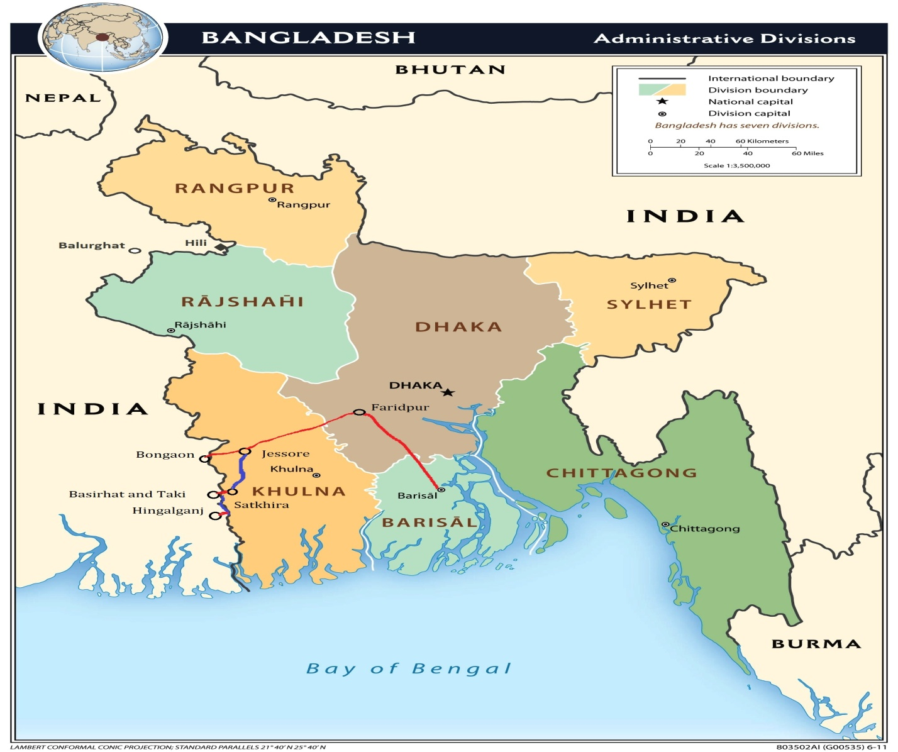

Map I: Bangladeshi Migration through Barisal, Faridpur, and Jessore to Bongaon (Benapole) and through Barisal Faridpur, Jessore, Satkhira (by launch) to Basirhat, Taki and Hingalganj.

Women who are caught in the Benapole Border and areas in Bongaon, Basirhat and adjourning areas are kept in mostly Alipore and Dumdum Correctional Homes. However, inmates are transferred regularly from one prison to the other. Mostly inmates from Krishnanagar and Bongaon correctional homes are sent to Alipore and Dumdum. While undertrials are kept in Alipore, convicts are transferred to Dumdum as it is a Central Correctional Home with more space and amenities. Infact, all Release Prisoners of Bangladesh who are also called “Jaan-Khalash” in the common parlance are sent from Alipore to Dumdum right after their period of conviction ends because it is from Dumdum that the repatriation process of these women takes place.

The routes generally used by inmates who are arrested and kept at Balurghat and Behrampore Correctional homes are:

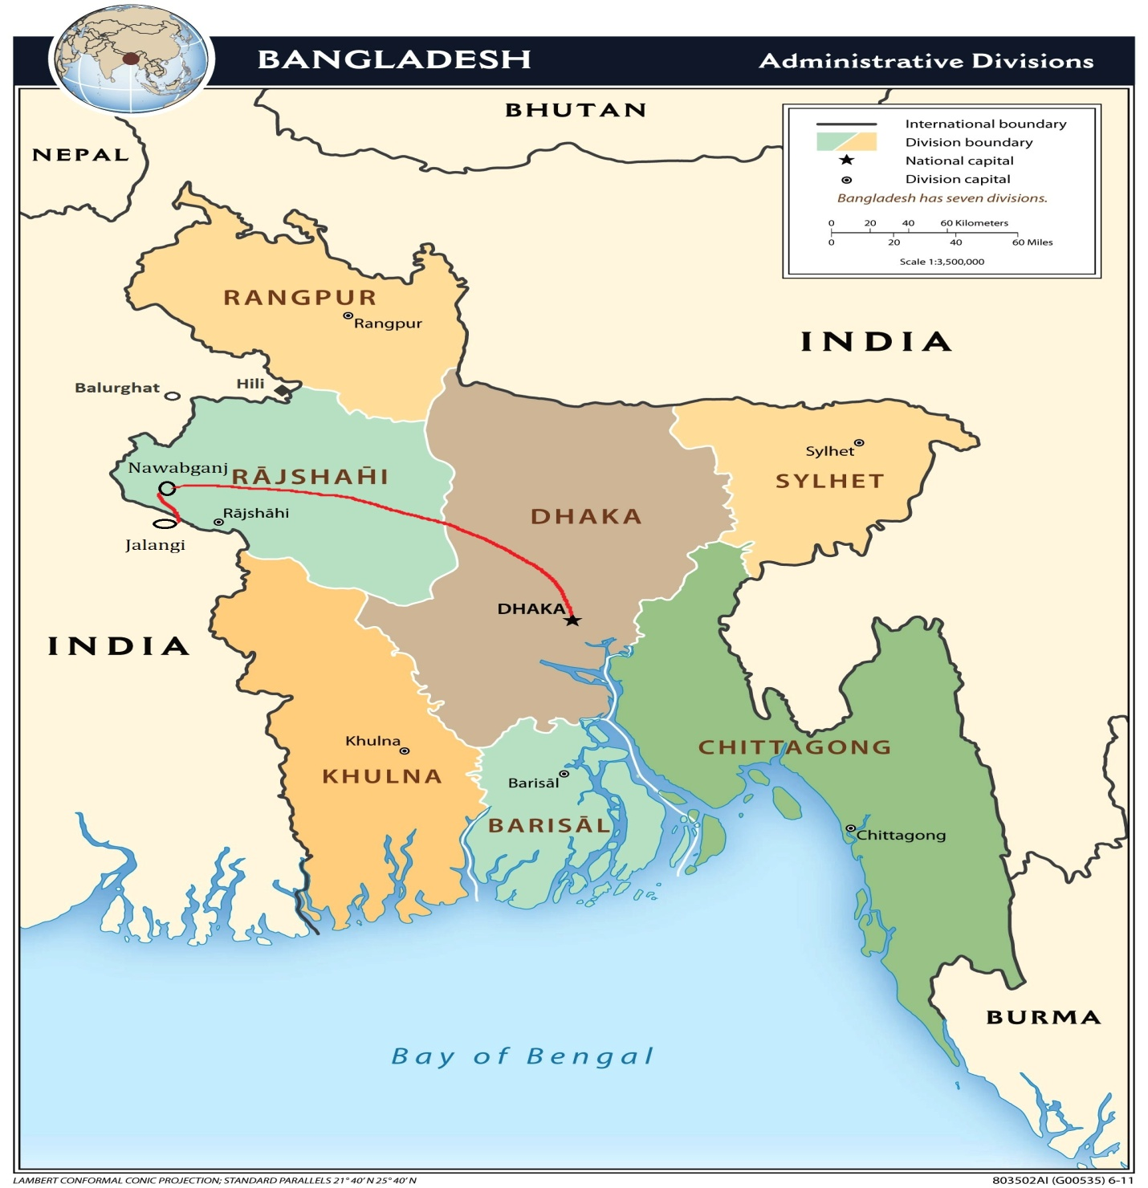

Map II: Bangladeshi Migration through Dhaka, Chapai, Nawabganj to Jalangi

Here also, a similar procedure takes place. Women from Malda, Coochbenar and Balurghat prisons are generally sent to the Behrampore as it is a Central Correctional home. The Balurghat district jail is very small in terms of capacity and hence no Bangladeshi convicts are kept here. After trial period, as soon as confinment starts, the women from Balurghat are sent to Behrampore so these two homes work closely with each other. The repatriation process too takes place from Behrampore. The four correctional homes studied for the present purpose have people coming from mainly Jessore, Chittagong, Khulna, Faridpur, Barisal and Dinajpur districts of Bangladesh and the transit point they mainly use is Dhaka. Due to the porous nature and absence of a clear cut demarcation of the border between the two Bengals there are many entry points through which the cross border flows take place. It is also natural that people are mainly caught from those points in the borderland which are the busiest in terms of trade between the two countries as border policing and securitizing it through proper mechanism becomes the priority of all states. Women who cross the Bengal border to come to West Bengal without proper documents are mainly helped by agencies operating at the border. There is even provision for making false documents like fake passports and visas. In this way, many women who cross the border are made to believe that crossing the border, even without valid documents is easy and smooth. There apparently is no harm in this particularly when for these middle men, crossing the Bengal-Bangladesh border are like a daily routine. Even when some of these women know that coming to another country without proper valid documents is illegal, they still come because they are *told* this won’t cause them anything, that there is an unwritten agreement with the Border Security Force regarding this. Many of these women thus regularly cross the border without documents until they get caught. As says Rita Mondal[8] (20 yrs, Bengali Muslim, place - Dumdum Correctional Home) that her original home is in Khulna and she works in a Brick factory in Delhi. She has crossed through Basirhat several times before without any problem but this time in her own words, “I was never caught before because the money paid to the security at the border was satisfactory. This time also I paid to the middle man Rs. 5000 but still I have been caught, I don’t know why”. This is the common practice highlighted by women who regularly cross the border through middle men in order to work here. They pay a sum which ranges anything from 3000 – 10,000 Rs to cross the border- apparently a sum within which they could easily get access to legal documents. On asking why don’t they make a passport which would cost them much less, the prompt reply that Rita gives is “It takes a lot of time and then we never had any problem before. Only this time I had a poor luck”. The Chief Officer of the Balurghat District Correctional Home, Souvik Sarkar has something interesting to say in this matter. According to him, “illegal infiltration across the Border is huge. The number is impossible to guess and only two percent gets caught, that too because in some areas there is an understanding between the Border Security Force (BSF) and the agencies that some cases would be handed over to the BSF deliberately”. This statement is corroborated by almost all women in Alipore Correctional Home who claim they are innocent and the “agents” have deliberately handed them over to the Police or BSF for reasons unknown to them. Bangladeshi nationals are mostly caught while commuting from one place to the other, especially in railway station, in trains or while commuting from the Borderland to areas they aim to go. A large number of Bangladeshi women work in the garments factories of Hyderabad, Brick factories in Delhi and in Mumbai and construction work in Gujarat. Mainly women from a poor economic background with

There are mainly four types of flows or reasons for which people come over to India from Bangladesh. – a) To visit relatives on the other side of the border b) For medical purposes or work c) For political disturbances; and particularly for women- d) Trafficked in name of work or marriage. d) Violence and Trafficking of Sex, labour and Goods:

I decided to address the elephant in the room in a separate stanza. Cross Border trafficking is not new and has been detailed in many works till date however what is interesting here is that trafficked women, mostly minor ageing below 18 yrs constitute the largest percentage of women who are jailed. Shahnaj Khatun[9], although the name does not really matter nor is it important as her story is not unique, is just one among hundred others who have crossed the border only to find further confinement in a correctional home in an alien land. For women like Shahnaj the notion of ‘freedom’ has forever remained elusive. Economic compulsions coupled with the prospect of a better life compel them to move out and step toward an unknown destiny. For some, the land is not alien; rather it is just a deal gone wrong. Shahnaj hails from Chittagong and says her age is nineteen although she hardly looks sixteen. Her home for the last month is the Alipore Women Correctional Home at Kolkata. Shahnaj had to take up work as a domestic aid at her a very tender age after her father died in order to support her mother, three sisters and two little brothers. She worked in two to three houses and received 300-500 rs per month which was very little to support the family; therefore managing the family was becoming a daunting task. One of the owners where she worked was kind. He was a regular to India and told her she could earn a lot more if she comes here. Shahnaj was happy. With new dreams towards a better life she set out with her *malik* (owner). Completely illiterate, she hardly knows what a border is and could not tell us which border she crossed to reach Kolkata. Her ordeal started once she reached Kolkata. Her malik sold her for Rs 20,000 to a man who brought her to a house where several women stayed, including many from Bangladesh. She was told by another young girl, *“kharap kaj hoe ekhane”* (dirty things happen here in name of work). Shahnaj cried, begged for freedom, but she was beaten up mercilessly, was forced to change into strange dresses that the other women in the home were wearing and lockup up in a room. She stayed here for two months, which was nothing short of hell to her. For each night, she was paid Rs 7000 but she was not given any money. From Kolkata Shahnaj was taken to a brothel in Delhi where she stayed fro more than a year. One day, when she was commuting from Delhi to another unknown destination with other women from the Delhi home, she was caught by the Police and taken to custody as she is an illegal migrant from Bangladesh. She was first taken to Durgapore jail, then one year in Asansole jail and finally in Alipore. She has been booked under the Foreigners Act and her prison term is for three years. Breaking down occasionally while she was talking, Shahnaj looked tired and fragile. It is not difficult to guess the amount of physical and mental pain that she has suffered each day after she left Bangladesh, her home. She now craves to back to her Ammu (mother). On asking whether she would ever come back to India, with a whisper and tears in her eyes she says “I don’t ever want to do this work again, never wanted to do. I don’t even like to stay here in jail either. I just want to go back but I don’t know what to do once I am back in my home. I do not even know whether I would ever be able to go back as I don’t know the way back…” her voice trails off here.

The everyday hardship or violence faced by women like Shahnaj is not hard to imagine. According to a report, girls from Bangladesh are largely trafficked for sex work and most of them are aged below 18. The most popular trafficking route employed by traffickers is Dhaka-Mumbai-Karachi-Dubai. Way back in 2004, the report says, around 200-400 women and children were trafficked to India each month totaling to approximate 10,000-15,000 annually. This number had increased manifold now at an alarming rate. One of the major reasons for this could be allotted to the collapse of the garment industry, one of the major sources of income in Bangladesh, more aptly Dhaka. In fact a lot of women who work in the Garments industry in Dhaka are victims of trafficking. They are also often sexually exploited by the owners of these industries. The poor work conditions in these industries coupled with meager salary makes it easy for girls working in garments to become an easy prey to offers like good job or marriage. The garment industry is crucial for the economy of Bangladesh and it employs around 4 million people annually of which 90% percent are young women below 19 years of age[10]. Most garment factories are situated in Dhaka and the pay scale is around 7000-8000 per month which is often not sufficient for the women working there. The opportunity to get better pay in another country therefore is alluring for them.

For instance, Saukina[11], aged 18 years have come from Gopalganj to India. She used to work in a garments shop in Dhaka. At the age of 12 she was married off by her step mother. Her father Siraj Mollah is a farmer in Gopalganj. She fled from her husband’s house one day after her husband remarried and she was made to do the daily household chores. A kind owner of garments factory gave her shelter in Dhaka, where she started working as a domestic aid. Gradually she learned stitching and works of embroidery and soon got a job in the shop of her owner, however she was paid very poorly. At this juncture, her husband started to visit her regularly. Her husband offered to start life with her afresh in India where work opportunities at garments were much better with a better pay package. Saukins believed him a second time and made the gravest mistake of her life. She left job with Sabuj Miyan, her husband and crossed the Benapole border through Bongaon. Once in India, they boarded a train towards Mumbai (she can’t recall from which station) when for the first time she became suspicious of the place where she was being taken to. There were other girls as well and two Indian men accompanying them to Mumbai. In midway, the whole group was arrested and booked under the 14(a) Foreigners act. Sabuj through his influences got himself released after shelling out Rs 50,000 as bail fee. Saukina’s case was tried in Basirhat Police Station and she has already spent a year and five months in jail but till now her charge sheet is due because her case partners are not making their appearances in court. Case partners are the persons with whom Saukina was caught by the police. The norm is all persons caught together should be produced together in court for trial and even if ne person does not appear before on the day when the court has summoned them for trial then the case gets deferred. What happens often in cases like Saukina’s is that the middle men or traffickers easily get themselves released either by paying hefty amounts or through connections and once they are out of the police custody they generally return back to Bangladesh or go under cover deliberately making themselves untraceable. Cases therefore remain pending.

In another instance, Yasmin was brought by her friend who works as a sex worker in a brothel in Hyderabad. Till landing to India by using the Bongaon- Basirhat area, Yasmin says, she was totally unaware of where she was being taken to. Once she started seeing through the truth, she confided to the officials in the Border Security Post of the Benapol border near Bongaon. She thought she would be released but she was instead sent to jail custody despite the fact that the prison officials also believe her. Her story ofcourse was vehemently denied by her case partner (the woman who brought her to India) who said Yasmin was lying completely and she has voluntarily come with her. In another case, Champa hailing from Faridpur was sold to a brothel in Orissa when she was just a child of 12. Since then she has lived in India. Now she is eighteen and while returning to her home in Bangladesh, atleast that is what she tells us, she was caught by the police and taken to jail custody under the passport act for using a fake passport.

Flow of goods and smuggling is also rampant in the border in particular Cattle smuggling as cows are illegally being stolen to Bangladesh. “While the formal trade relations are beginning to emerge from its nascent stage, illegal trade along the border has been thriving for long”. The meat industry and Bangladesh’s thriving leather industry is booming due to cattle smuggling from India at a throw-away price’[12]. The cross-border flow of capital and illicit trade is facilitated by a strong network of agencies or middle men operating at the border. The smuggling of Phensedyl, is also a popular item of smuggling. The usual suspects are the persons living nearest to the zero point of the border. Often without concrete evidences the Border Security Forces (BSF) interrogates the people there. Testimonies of violence are many, countless in fact. Farid Mondal, a resident of Hatkhola village- a bordering land in the district of Nadia says their area is inhabited by Musilms. Hatkhola is a border between Nadia district in West Bengal and Munshipur in Bangladesh. People in the Hatkhola village are always looked as suspects whenever any unnatural incidence takes place. Instances of harassment of the locals there have increased manifold with the incident of Khagragarh bomb blast. Mondal was attacked brutally one day by some BSF while on his way back home from the field where he works as a farmer. In his own words, “the BSF asked me to give them the names of persons involved in cattle and goods smuggling. I said I do not know. On hearing this, they dragged me to their camp, I managed to escape somehow”. The next day they came to my house bringing seven more jawans with them, beat me mercilessly, my wife was also attacked. Both of us were hospitalized later by the locals in a nearby hospital in Chapra. I broke my leg and we are yet to recover from the mental trauma and pain”. At the time of this interview, BSF Batillion 119 was posted there. Some neighbours of Mondal also narrated incidents like these that they face on a regular basis. They believe it is also because they are a minority that instances of violence are so many in their locality.

**The confined lives- rights and problems: (Section I)**

The line between a legal migrant and an illegal migrant often gets blurred in the context of the Bengal-Bangladesh cross border migration. There are zones which belong to the Indian Territory but inhabited by Bangladeshi people and vice – versa. For instance, *Char Meghna*, a place in Murshidabad belongs to Bangladesh officially but people of Indian nationality stay there. Similarly *Jamalpur* is another place in Murshidabad which belongs to the Indian Territory but Bangladeshi nationals live there. The uniqueness of the Bengal Bangladesh border lies here. More than diving geographical territories, it has divided relations, homes, and hearts. All of a sudden people found themselves being called as “foreigners” in their own land. Either they have to accept their belonging to another country now or they leave. In cases like this, the border gets subverted. Simply put, to cross an international border without a permit is considered illegal and any attempt in this regard is an offence punishable under the Indian Penal Code. While talking to the women in the correctional homes one cannot help but wonder whether even after so many years of partition of the Indian Territory the absence of the legal implications of the “border” is deliberate. Flows across the Bengal-Bangladesh border are as normal as the border itself as for the people in both sides of the border “affinal ties remain”[13]. Securitization of the border through passport and visa was introduced in 1949 and 1952 respectively. The more the eastern part of the border has been securitized, the more it has given rise to incidents of violence and illegality like smuggling and trafficking of women and children across the border.

It is very difficult to get the exact figures of illegal immigration from Bangladesh to India. One way of doing so could be to study the number of Bangladeshi nationals in prisons of Bengal. A local vernacular from the border area reports in January 2014 that prisons in West Bengal are increasingly being flooded with people from Bangladesh, in particular the prisons of Dumdum in Kolkata and Balurghat in South Dinajpur which have the maximum number of Bangladeshi nationals. As a result of this increase in number, the prisons are even having space crisis. The capacity of all correctional homes in West Bengal is 20 thousand inmates, while figure in 2013 was 23,000 inmates including the Bangladeshi Nationals. The news article also presents a rough data of Bangladeshi nationals arrested from July – December 2013:

July – 3500

August- 3700

September- 3400

October – 3800

November – 4000

December – 3700 (In 2011 and 2012 Bangladeshi nationals were at least less by 1500-2000.

The data of this year is tabled below:

|  |  |  |  |  |  |  |  |  |  |  |  |  |  |
| --- | --- | --- | --- | --- | --- | --- | --- | --- | --- | --- | --- | --- | --- |
| Bangladeshi National (BDN) Population in the concerned four Correctional Homes of West Bengal from June 2014 to January 2015 | | | | | | | | | | | | | |
| **Name of Correctional Home** | **Month and Year** | **No. Of BDN Convict** | | **No. Of BDN Under Trial Prisoners** | | **No. Of BDN Jan Khalash** | | **No. Of BDN Children** | | **Total** | | **Grand Total** | **% of females** |
| **Alipore Women C.H.** | 01.06.2014 | ***M*** | ***F*** | ***M*** | ***F*** | ***M*** | ***F*** | ***M*** | ***F*** | ***M*** | ***F*** |
| 0 | 7 | 0 | 25 | 0 | 3 | 2 | 1 | 2 | 36 | 38 | 95 |
| 01.07.2014 | 0 | 9 | 0 | 19 | 0 | 4 | 1 | 1 | 1 | 33 | 34 | 97 |
| 01.08.2014 | 0 | 9 | 0 | 17 | 0 | 2 | 1 | 0 | 1 | 28 | 29 | 97 |
| 01.09.2014 | 0 | 10 | 0 | 18 | 0 | 2 | 1 | 0 | 1 | 30 | 31 | 97 |
| 01.10.2014 | 0 | 9 | 0 | 15 | 0 | 0 | 1 | 0 | 1 | 24 | 25 | 96 |
| 01.11.2014 | 0 | 7 | 0 | 29 | 0 | 3 | 6 | 2 | 6 | 41 | 47 | 87 |
| 01.12.2014 | 0 | 10 | 0 | 43 | 0 | 3 | 7 | 4 | 7 | 60 | 67 | 90 |
| 01.01.2015 | 0 | 5 | 0 | 8 | 0 | 1 | 1 | 2 | 1 | 16 | 17 | 94 |
|  | | | | | | | | | | | | | |
| **Dum Dum Central C.H.** | 01.06.2014 | 298 | 31 | 249 | 48 | 504 | 68 | 25 | 48 | 1076 | 195 | 1271 | 15 |
| 01.07.2014 | 267 | 19 | 272 | 60 | 269 | 41 | 17 | 40 | 825 | 160 | 985 | 16 |
| 01.08.2014 | 249 | 19 | 352 | 70 | 118 | 39 | 26 | 47 | 745 | 175 | 920 | 19 |
| 01.09.2014 | 249 | 37 | 352 | 73 | 332 | 55 | 28 | 50 | 961 | 215 | 1176 | 18 |
| 01.10.2014 | 163 | 27 | 293 | 43 | 189 | 58 | 20 | 40 | 665 | 168 | 833 | 20 |
| 01.11.2014 | 194 | 12 | 304 | 71 | 183 | 25 | 29 | 44 | 710 | 152 | 862 | 18 |
| 01.12.2014 | 342 | 16 | 485 | 57 | 244 | 36 | 55 | 42 | 1126 | 151 | 1277 | 12 |
| 01.01.2015 | 431 | 22 | 354 | 49 | 311 | 49 | 66 | 55 | 1162 | 175 | 1337 | 13 |
|  | | | | | | | | | | | | | |
| **Berhampore Central C.H.** | 01.06.2014 | 153 | 30 | 8 | 2 | 90 | 5 | 10 | 10 | 261 | 47 | 308 | 15 |
| 01.07.2014 | 200 | 35 | 16 | 3 | 16 | 0 | 1 | 7 | 233 | 45 | 278 | 16 |
| 01.08.2014 | 194 | 37 | 15 | 2 | 39 | 0 | 11 | 11 | 259 | 50 | 309 | 16 |
| 01.09.2014 | 178 | 37 | 18 | 3 | 62 | 2 | 11 | 11 | 269 | 53 | 322 | 16 |
| 01.10.2014 | 243 | 41 | 16 | 4 | 32 | 0 | 12 | 13 | 303 | 58 | 361 | 16 |
| 01.11.2014 | 258 | 42 | 28 | 4 | 56 | 1 | 2 | 6 | 344 | 53 | 397 | 13 |
| 01.12.2014 | 282 | 44 | 38 | 4 | 68 | 2 | 3 | 7 | 391 | 57 | 448 | 13 |
| 01.01.2015 | 234 | 29 | 38 | 4 | 68 | 2 | 5 | 6 | 345 | 41 | 386 | 11 |
|  | | | | | | | | | | | | | |
| **Balurghat District C.H.** | 01.06.2014 | 146 | 7 | 174 | 35 | 0 | 0 | 11 | 8 | 331 | 50 | 381 | 13 |
| 01.07.2014 | 118 | 3 | 155 | 21 | 0 | 0 | 10 | 7 | 283 | 31 | 314 | 10 |
| 01.08.2014 | 121 | 4 | 129 | 19 | 0 | 0 | 10 | 7 | 260 | 30 | 290 | 10 |
| 01.09.2014 | 154 | 5 | 158 | 29 | 0 | 0 | 10 | 8 | 322 | 42 | 364 | 11 |
| 01.10.2014 | 107 | 2 | 154 | 27 | 0 | 0 | 7 | 5 | 268 | 34 | 302 | 11 |
| 01.11.2014 | 110 | 2 | 238 | 34 | 0 | 0 | 10 | 7 | 358 | 43 | 401 | 11 |
| 01.12.2014 | 73 | 2 | 263 | 33 | 0 | 0 | 9 | 5 | 345 | 40 | 385 | 10 |
| 01.01.2015 | 88 | 2 | 280 | 36 | 0 | 0 | 9 | 6 | 377 | 44 | 421 | 10 |

*Source: ADG & IG of Correctional Services, Directorate of Correctional Homes, Govt. Of West Bengal [14]*

*Note: Percentage data are rounded off*

The total number of Convicts, under trail persons and children in all correctional homes of West Bengal are tabled below:

|  |  |  |  |  |  |  |  |  |  |  |  |  |
| --- | --- | --- | --- | --- | --- | --- | --- | --- | --- | --- | --- | --- |
| Bangladeshi National (BDN) Population in All Fifty Eight Correctional Homes of West Bengal from June 2014 to January 2015 | | | | | | | | | | | | |
| **Month and Year** | **No. Of BDN Convict** | | **No. Of BDN Under Trial Prisoners** | | **No. Of BDN Jan Khalash** | | **No. Of BDN Children** | | **Total** | | **Grand Total** | **Percentage of Females** | |
| 01.06.2014 | ***M*** | ***F*** | ***M*** | ***F*** | ***M*** | ***F*** | ***M*** | ***F*** | ***M*** | ***F*** |
| 752 | 83 | 1464 | 203 | 681 | 78 | 61 | 78 | 2958 | 442 | 3400 | 13.00 | |
| 01.07.2014 | 819 | 73 | 1429 | 179 | 313 | 47 | 41 | 64 | 2602 | 363 | 2965 | 12.24 | |
| 01.08.2014 | 801 | 80 | 1427 | 181 | 192 | 43 | 64 | 79 | 2484 | 383 | 2867 | 13.36 | |
| 01.09.2014 | 818 | 107 | 1434 | 209 | 434 | 63 | 64 | 81 | 2750 | 460 | 3210 | 14.33 | |
| 01.10.2014 | 775 | 87 | 1224 | 162 | 254 | 65 | 51 | 65 | 2304 | 379 | 2683 | 14.13 | |
| 01.11.2014 | 783 | 71 | 1695 | 235 | 261 | 35 | 59 | 70 | 2798 | 411 | 3209 | 12.81 | |
| 01.12.2014 | 936 | 83 | 1787 | 237 | 330 | 46 | 83 | 67 | 3136 | 433 | 3569 | 12.13 | |
| 01.01.2015 | 1037 | 71 | 1628 | 191 | 444 | 56 | 93 | 78 | 3202 | 396 | 3598 | 11.01 | |

*Source: ADG & IG of Correctional Services, Directorate of Correctional Homes, Govt. Of West Bengal (Data collected on 25.02.2015)*

The study of these figures offers an interesting dimension that while in adults men are migrating more, just the reverse is occurring in case of children. This could mean two things, either young girls are being mostly trafficked or sent or sold by their families for an earning. Infact age is an issue of contention for Bangladeshi women who are in prison as most of the women there are below eighteen years but they claim they are either eighteen or above eighteen either because they are taught so or because they are unaware of their age and taking that opportunity the officials while filing charge sheet deliberately make them adults to avoid responsibility. Children and adolescents below eighteen are not supposed to be sent to Homes’ run by various nongovernmental organizations instead of prisons. Also the total number of Bangladesh nationals has remained same more or less as compared to the last year. The space crunch is further aggravated by the fact that the released prisoners of Bangladesh are not being repatriated in time and hence even after release many are staying back for an indefinite period. According to this report, the Jail minister Ajij Safi has said that steps are being taken to timely repatriate the prisoners in consultation with the Deputy High Commissioner of Bangladesh. According to another official of the Jail Directorate, the neighbor country is not much willing to take back ten released prisoners and hence a long detention for them is becoming a norm[15].

One of the major problems that the women in these correctional homes face is the issue of children, especially minor, who are brought to India by their parents. When the parents are arrested and sent to judicial custody, the children above 6 years are presented in front of the Child Welfare Committee and Juvenile Justice Board and then sent to children homes, separated from their parents. While this could have been a positive step this causes a lot of worry and anxiety to the women concerned because for some of them they don’t get to see their children for long, even after their conviction ends! Adding more to the misery is the fact that the mothers and their children are not repatriated together. Often the women go back to their home place but children are left behind because of the long process of repatriation which I have explained in a following stanza. The homes where these children are mostly kept are Kishalaya Home, Sneha, Sahid bandana Smriti Abas, Ananda Ashram and Malda District Shelter Home among others.

The Welfare Officers of Dumdum, Behrampur and the Superintendent of Balughat Correctional Home also expressed their worry and concern about this problem as this is causing mental trauma to most women in the respective correctional homes who have come with their children.

**Law/ Repatriation/Push back –myths/reality: Section II**

In general, the first thing that the Prison authorities tell people who want to visit or interact with inmates from Bangladesh is that they are all booked under the section 14 of the Foreigners Act, either 14(a), 14 (b). The case files shown t us by most of the interviews also testifies this. The Foreigners Act was introduced to the constitution of India in 1946 and later amended in 2004. The Original Act lays down in detail as to who a foreigner is and the general procedure that a foreigner has to follow in order to enter India. In a nutshell the act says, A foreigner “(a) shall not enter India or shall enter India only at such times and by such route and at such port or place and subject to the observance of such conditions on arrival as may be prescribed; (b) shall not depart from India, or shall depart only at such times and by such route and from such port or place and subject to the observance of such conditions on departure as may be prescribed; (c) shall not remain in India or in any prescribed area therein ;… (e) shall comply with such conditions as may be prescribed or specified- (i) requiring him to reside in a particular place; (ii) imposing any restrictions on his movements; (iii) requiring him to furnish such proof of his identity and to report such particulars to such authority in such manner and at such time and place as may be prescribed or specified;”[16]. The section 14 of the act had laid down the penalties and said any person contravening the provisions of this act shall be liable to a period of “imprisonment for a term which may extend to five years and shall also be liable to fine”[17]. The problem with thee section 14 of this act prescribing penalty was an absence of clarity, probably for which this section was amended in 2004 through the Foreigners (Amendment) Act. The Amended act says that the earlier section 14 of the Act would have to be substituted with the new section 14. According to the amended section, a person who is not a citizen of India could be penalized if he/she “remains in any area in India for a period exceeding the period for which the visa was issued to him; does any act in violation of the conditions of the valid visa issued to him for his entry and stay in India or any part there under.” [18] The penalty for this would remain five years along with fine like the original section of the act and section 14 (a) which is applied for Bangladeshi nationals in prisons in West Bengal, penalizes whoever – “(a) enters into any area in India, which is restricted for his entry under any order made under this Act…without obtaining a permit from the authority, notified by the Central Government in the Official Gazette, for this purpose or remains in such area beyond the period specified in such permit for his stay; or (b) enters into or stays in any area in India without the valid documents required for such entry or for such stay, as the case may be, under the provisions of any order made under this Act… shall be punished with imprisonment for a term which shall not be less than two years, but may extend to eight years and shall also be liable to fine which shall not be less than ten thousand rupees but may extend to fifty thousand rupees.”[19]. Section 14 (b) penalizes any person who is using a forged passport. It says, “Whoever knowingly uses a forged passport for entering into India or remains therein without the authority of law for the time being in force shall be punishable with imprisonment for a term which shall not be less than two years, but may extend to eight years and shall also be liable to fine which shall not be less than ten thousand rupees but may extend to fifty thousand rupees”[20].

It is true that the general trend for persons of Bangladesh who are caught for illegally entering into the Indian Territory without having valid documents like a valid passport or visa are booked under the aforesaid acts [14 (a) or (b)] and the confinement period is minimum two years. The term extends to some more months if the detainee is unable today the stipulated fine. However, before the amendment of the section 14 in 2004 the terms of confinement used to be longer. Again, even after the act was passed in 2004, the practical application had taken time to be implemented and often the difference in terms varying from person to person has not been justified. The case of Bhaduribala (40) for instance, has already spent 7 long years in Behrampur Central Correctional Home. She had come with her two children who were little kids when they came and have now grown into adults and live in homes assigned to keep Bangladeshi children who have come with their parents to West Bengal. Bhaduribala is a Hindu who, as she claims, was forced to leave her country, more precisely Sankarpur Village in Dinajpur, to come to her relatives place in India owing to political unrest in Bangladesh. She had paid a sum of Rs 5000 to her lawyer and yet - she grumbles with tears in her eyes – no progress has been made in her case. She has last seen her daughter who stays in ‘Sahid Bandana Smriti Abas’ in Coochbehar six years ago. Her son stays in Balurghat home and was last brought to see her four years back. Bhadhuribala is happy that her children unlike her is getting education in the homes they are residing but the fact that she can hardly get to see her children adds to her misery. She doesn’t even know when they would be released and whether at all they could go back to their home together. Questions like if they are not able to go back to Bangladesh then where could they get shelter, worries her a lot. Almost all Bangladeshi inmates in prisons of West Bengal are victims of administrative apathy. In a news article in 2012, a similar situation was reported. It says how Rangabala Sarkar (84), a resident of Sirajgunj in Bangladesh has not been released despite getting a bail in 2009. According to the report, as many as 592 Bangladeshi inmates have been suffering in several jails in West Bengal, including 112 children. As per data received till 2011, total number of released Bangladeshi prisoners (jaan khalash) was 480, under trail persons – 776 and convicts – 792. Lack of a speedy and short process of repatriation on both sides of the border is the main cause behind the suffering of many innocents in the prisons of both countries[21].

There is a lack of uniformity or adhocism as to the charges under which women from Bangladesh are booked. For instance, the cases of Yasmin and Champa briefed above were booked under the Foreigners Act although there were clear evidences of them being trafficked victims. However there are some exceptions too where in Bangladeshi nationals have been booked under other IPC Acts. It is interesting to note in this context the case of Lisa Begum whose age is 21. She along with her two sisters were taken to Hasnabad Police Station as they were caught after crossing the Basirhat- Bongaon Border and then sent to the Dumdum Central Correctional Home. She has come to India with her two sisters who are aged 19 and 18 respectively and all the three sisters have been booked under the IPC 363, 365 and 366 B along with 14(a) and 14(b) of the Foreigners Act. The section 363 of the IPC says, “Punishment for kidnapping—whoever kidnaps any person from 1[India] or from lawful guardianship, shall be punished with imprisonment of either description for a term which may extend to seven years, and shall also be liable to fine” [22] and according to the IPC 365, “Whoever kidnaps or abducts any person with intent to cause that person to be secretly and wrongfully con­fined, shall be punished with imprisonment of either description for a term which may extend to seven years, and shall also be liable to fine”[23]. Section 366-b of the Indian Penal Code says that “Whoever imports into 2[India] from any country outside India 3[or from the State of Jammu and Kashmir] any girl under the age of twenty-one years with intent that she may be, or knowing it to be likely that she will be, forced or seduced to illicit intercourse with another person, shall be punishable with imprisonment which may extend to ten years and shall also be liable to fine.[24]

The sisters hail from Mirpur, Dhaka. They have already spent two months in the Dumdum Central Correctional home under an ambience of anxiety and sorrow. They do not know the cases under which they have been booked. All they could tell us were “we came to India because our sister also stays here, in Bangalore and regularly visits us in Bangladesh. We had no clue regarding the procedure to come here and came with her husband. Clearly, the sisters have been trafficked from Bangladesh in all probability to be sold for flesh trade. But the problem is only the sisters have been caught while the middleman who has brought them has managed to escape. As a result their case is remaining pending and the charge sheet is also not being prepared and instead of returning safely to their home, the girls are suffering, spending their days in prison, away from home, in an alien land. They are unaware the cases under which they would be tried or what could be their prison term. Questions that raises rightfully here are who are at guilt here - are these girls, young and naïve, unaware of am impending danger, solely on the basis of trust have crossed the border are at fault or the system which victimizes them.

There are at present 58 correctional homes in West Bengal and three types of Bangladeshi nationals in any correctional home- Under trial, Convict and Released Prisoner or what is in colloquial parlance known as ‘Jaan-Khalash’. The capacity of Central correctional homes is the most compared to district or sub jails and hence they house most number of convicts. In North Bengal, Behrampur Central Correctional Home has most number of convicts both in terms of Indian and Bangladeshi nationals and in case of the South- it is the Dumdum Central Correctional home which has the maximum number of convicts. The figures of inmates in correctional homes change everyday. Approximately, in the month of November, Alipore Women Correctional home had 18 under trial women and 5 release prisoners, Dumdum had 2509 Indian inmates and 400 Bangladeshi nationals, Behrampore – 245(Male) and 37 (women) Bangladeshi nationals and Balurghat – Bangladeshi nationals- 272 (male) and 35 (Female), Myanmari Nationals – 8 Women (undertrial) It is imperative to mention here that Bangladeshi under trails and released prisoners are much more in number in all these four correctional homes than the number of convicts. It is because barring a few exceptions, almost all Bangladeshi nationals caught for trespassing illegally across the border are booked under the Foreigners Act and mostly all under trials are convicted for a period of two years (and two year two months incase the detainee is unable to pay the fine fixed by the court) which is the stipulated minimum punishment for persons booked under the Foreigners Act. Hence the common practice is that, by the time the term of conviction is announced by the court; the person concerned has already spent that period in prison or is nearing the completion of the term. So, for most Bangladeshi nationals, the status of ‘under trial’ changes to ‘released prisoner’ instead of ‘convict’. Once a person becomes a release prisoner, i.e, his/her period of confinement comes to an end, the process of repatriation starts. The entire process of repatriation is long, tedious and lengthy which I would explain in the following stanza.

According to the West Bengal Correctional Service ACT 1992, “Rehabilitation assistance” means financial or any other assistance given to a released prisoner for the purpose of his rehabilitation into the society as an ordinary citizen”[25] – For Women inmates of Bangladesh this rarely takes place. Rather the fate of a release prisoner of Bangladesh is full of uncertainty. There is confusion even among jail authorities regarding the exact process of repatriation of the inmates. The myth is, ‘Push back’- a colloquial term used to define the process of literally pushing back people of Bangladesh back to their home from the Indian Territory does not exist anymore. Reality is however otherwise, and extremely harsh. In course of my various rounds of discussion with the prison authorities in all the four homes that we visited, everyone from the superintendant to the welfare officer admitted that Repatriation, i.e, the official procedure to send back a person back to Bangladesh happens rarely and instead what takes place is deportation or pushback. Let us now have a close look at the two systems.

Repatriation is an indeed long process where governments of both the countries are involved in securing the return of a migrant/infiltrator. On May 2014, the West Bengal Government has set up a Task Force to repatriate victims of trafficking to Bangladesh[26]. In another recent meeting, the government has agreed upon the process of repatriation that should be applied for mainly women and children of Bangladesh, especially children, who are much more prone to be victims of trafficking. According to the Operational Guidelines on rescue and repatriation of women and children, especially the victims of trafficking back to their homeland a task force has been created. This task Force would monitor the process of repatriation of rescued women and children safely back to their country of origin. The procedure is explained through a number of steps:

1. The Victim- be it a child or a woman after being rescued by the Police or Border Security Force (BSF) or any Non- Governmental Organisation (NGO) has to be thoroughly and carefully interrogated so as to differentiate between a victim and a trafficker. [Vide Ministry of Home Affair’s Advisory dated 1-5-2012 No. 14051/14/2011-FVI).
2. Since children are even more vulnerable and prone to being victims of trafficking they are in need of extra care and protection (CNCP) as defined in the Juvenile Justice, Care and Protection of Children Act, 2000, they would be first placed before the Child Welfare Committee (CWC) and sent to the government or home run by any NGO.
3. This point is most important as the guideline says, if a foreign child is found to be the victim of trafficking then he/she should not be prosecuted under the Foreigners Act (MHA’s advisory dated- 1.5.2012) and to be placed in children’s home within one week.
4. A request would be sent to the respective State Task Forces Secretariat for the address verification of the trafficked person in country of origin with copies to relevant authorities like – District Superintendent of Police, District Magistrate, Director of Social welfare, Women and Child Development and the West Bengal Task Force Secretariat, with all documents relating to the case confidentially.
5. After this is done, the State Task Force Secretariat would send a request for identity and address verification of the concerned person, with necessary documents to Branch Secretariat of Ministry of External Affairs (MEA) at Kolkata through the Home (Foreign &Non Residential Indian[27]) section, with intimation to the National Task Force at the MHA.
6. The State Task Force as well as the National task Force will regularly review the progress regarding the identity/ address verification.
7. The Bangladeshi Deputy High Commission (BDHC) would expedite family tracing and inform back within 45-60 days. Or the Bangladesh High Commission might also issue temporary travel documents. The entire set of travel documents would then be sent to the State Home Department with intimation to the State Task Force. The State Home Department (F&NRI) would have to issue a no-objection certificate to facilitate the return of the trafficked person. The shelter home-in charge has to also issue a release order which has to be submitted to the West Bengal task Force Secretariat, after which the home in charge would keep the trafficked victim ready with all relevant documents required during departure like case file, case history etc. In the meantime the West Bengal task Force Secretariat would consul with the counterpart Task Force or NGO as nominated by the Task Force in Bangladesh for the safe homecoming of the trafficked victim.
8. In case of children, after all the above steps are done, the Director of Intelligence Bureau (DIB) in consultation with the BSF, West Bengal Task Force Secretariat and selected NGO would make arrangement for the transportation of the child along with the case file to Border for repatriation by land. The child would be handed over by eh BSF to the Border Guards of Bangladesh (BGB), in the presence of the BSF & NGOs of both sides.

The time taken for this entire process for return and closing of file should take around 21 weeks as per the Order[28]. However, how far this has been implemented by the concerned officials is debatable. In particular, for women who are in correctional homes this system of repatriation has taken place very rarely. This is the ideal process in which the persons should be sent back to their home but this hardly has been a practice till now. With a few exceptions, the norm has mostly remained a horrible system of forcefully sending them back to their homeland mainly during nights. As the Welfare Officer of Behrampore, S. Mali says, “the unofficial system that takes place is push back. A report of Released Bangladeshi prisoners is submitted by the Jail Superintendent to the nearest Border Security Force. The BSF then gives a date when the police visit the jails to transfer the released prisoners to the BSF. From this point the women are left on their own to go back. Implementation of the proper process of repatriation also becomes difficult as people who cross the border illegally are generally people without resources, belonging to very low economic background and are mostly uneducated, as a result of which authentication of their identity is very difficult to prove. The release prisoners who are ready to be sent back from judicial custody are taken to the nearest border check posts by the police and then handed over to the BSF. There is an understanding between the BSF and the BGB that the whole operations of sending back the released prisoners would take place in absence of the BGB, so that an official seal on the whole process could be denied.

**Merged Identities/nationalities/statelessness:**

The vulnerability of the Bengal-Bangladesh Border gets even clearer with a visit to the Balurghat Correctional Home in South Dinajpur, a place very low in development, poor transportation and remote in terms of accessibility. South Dinajpur is basically a part of the West Dinajpur district which has been created out of the erstwhile Dinajpur District during the partition of India in 1947. The rest of the Dinajpur District is now in Bangladesh. With partition suddenly the region was divided into two countries but the socio-cultural similarities across the border could hardly be over emphasized. It is surrounded from three sides by Bangladesh, one side by Malda and one by North Dinajpur. As a result, the nearest border point of South Dinajpur – Hili- is an important point of trade between the two countries. According to a local news report of Balurghat[29], Dakshin Dinajpur is surrounded by Bangladesh on three sides and it is here through which infiltrators enter and the crux of the story is that mainly Rohingya Muslims enter through this border apart from regular Bangladeshis. The Rohingyas are basically inhabitants of the Arakan province of Myanmar and were compelled to flee their home following a series of civil wars[30]. They are basically now a stateless community within Myanmar as per a citizenship law in 1982. The Hilly border is very important because it is through here that Rohingyas are entering into India through Bangladesh- mainly Chittagong and Cox’s Bazar. The following map (Map III) highlights the route mostly used by them to enter India. Although the UNHCR has been issuing Refugee Cards to the Rohingyas in order to give them the Refugee Status, they are being arrested and put behind bars for illegal infiltration. The major problem is that there is a general lack of awareness among the authorities concerned regarding the policy to be followed in case of Rohingyas. Often the persons who are caught do not even divulge their true identity and declare themselves as Bangladeshi thinking that might go in their favour. According to a news report, a person was arrested recently for being suspected as a terrorist as he could speak seven different languages. However, on being caught he said that he was a Rohingya and after police interrogation declared himself to be a resident of Kolkata.[31] Another report stated of an increasing involvement of school students and youth in illegal business in the border areas, particularly in Dhalpara Pagyul and in other villages under Hili Gram panchayat.[32] Smuggling of cow, Phensedyl, spices and drugs like heroin are smuggled rampantly through the Hilly border and women are often used as carriers as says the day Jail super K. Ghosh.

At the time of this research Balurghat Correctional Home had 8 Rohingya Women officially[33]. The eight women have come together in a group of 20 from Fanshi, Quarbil, Bali Bazar, Bugrishaw and Bohbazar areas of Rakhine District, Myanmar[34]. All of them – Noorjahan, Nurkalima, Belma, Mumtaz Begum, Samjhu Nahar, Manohara, Mabia Khatun and Fatema Khatun said they were compelled to flee for mass violence that was unleashed on them from a long time. Fresh vethnic violence has erupted since 2001 devastating them. Their children were not allowed to go to Madrassas (educational institutional designed for Muslim children), they were not allowed to pray, not allowed movement. Some of these women have lost their husbands to brutal torture. They have come through Chittagong in Bangladesh, via a long route to reach India in order to go to Jammu where already some of their relatives have settled in the Rohingya camps. Even the Dumdum Correctional home and Behrampur Correctional Home now have a considerable number of Rohingyas and their fate is even graver than the Bangladeshi nationals since they are basically a stateless community. This means that they cannot be repatriated or sent back to their country as the government of Myanmar does not recognize them as citizens and try pushing them to Bangladesh. So repatriating them is difficult. Most of them claim their nationality as Bangladeshis but the difference in linguistic and cultural traits gives them away easily. Therefore even after a Rohingya becomes a Jaan khalash, he/she suffers in prisons till a decision is reached. Like Mumtaj Begum (30 yrs) has already spent a year and nine months in confinement in Balurghat. She has four children of all of whom are staying at two homes. Despite serving a prison term of 19 months she still remains an under trial without appearing even once at the court.

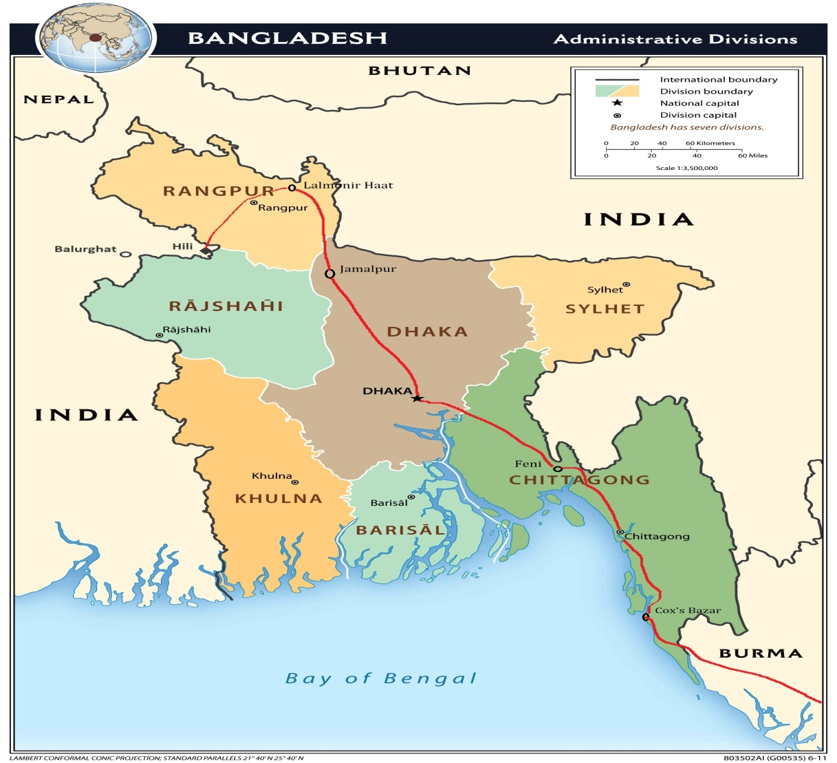

Map III: Rohingya Migration from Myanmar to Hili through Cox’s Bazar, Chitagong, Feni,

Dhaka, Jamalpur, Lalmonir Haat, and Dinajpur**.**

The Balurghat Correctional Home has however directly made contacts with the Delhi office of UNHCR in order to rehabilitate the Rohingyas in refugee camps particularly those women who already have got refugee cards like Noorjahan. The Jail Superintendent is regularly in touch with the officials concerned in UNHCR, Delhi; the process again takes up a lot of time. The interesting thing is that Balurghat is trying this completely out of their personal initiative. But for the Rohingyas in other prisons, the wait is ceaseless. Some, we are have spent almost two years in prison after release just because a consensus has not been reached regarding where and how they would be resettled.

**The Way Forward?**

According to a public statement issued by the Amnesty International way back in 2003 states that, no person regardless of nationality or legal status should be subject to arbitrary arrest or detention, i.e, in absence of any recognizable criminal offence no person should be arrested. It also suggests that any person with a contested nationality or who is unable to prove his/her identity shall have full access to an accountable body to establish legal rights (Chapt 5: 67). The Amnesty International had urged both the governments of India and Bangladesh to accept this guideline in order to protect the rights of persons who have “illegally” crossed the Bengal-Bangladesh Border. However, still now this has remained only as a suggestion in papers. The multifarious problems of the border are many as we could decipher from the above discussion and solutions apparently very few. Living on the margins is not easy as a population that lives on the edges are fated to be subjugated and marginalized by the state apart from constantly viewed as suspects or criminals. Often, the implications of criminality, the intimidating silence and penetrative gaze of the border forces are much more subjugating than any physical form of violence. For women who are trafficked or have crossed the border for economic reasons and then jailed subsequently, extreme sexual and gendered violence is not hard to imagine. Violence for them is not only physical but structural, embedded in the system in general. The entire journey from home to a prison, living under abject uncertainties, not knowing what lie ahead reeks of extreme violence and might spell trauma for most of them for the rest of their lives. Xenophobic violence coupled with sexual violence has become a routine for residents in the Bengal-Bangladesh Borderland. Interesting here is how women are learning to negotiate with these by juggling multiple identities and turning victimhood as a weapon of survival.

Failed state negotiations and inability of officials to table a decision has further aggravated the problem. The precariousness of the borderland coupled with vested interests has normalized the flow of persons and smuggling of goods. Half of the times women who are caught for trespassing through the border are denied justice simply because they do not tell the truth. It is also evident that most of the times they are taught what exactly and how much they should reveal in judicial custodies which makes things only difficult for them. Often there is fear from which these women do not reveal the names of persons who are bringing them here or how they are being brought. They know that they are under constant surveillance since the agents who bring them here get to know eventually what they confess in courts. What are interesting for these women are the constant negotiations that most of them do in order to cross the borders either while entering or while being repatriating by using their body[35]. They are no longer victims but through different names and forged identities they have normalized the abnormal in their lives. The Bengal Bangladesh Border is therefore no more a separate space; it has moved right into the heart of the nation state and is encroaching on the space within. Instead of at the periphery it has become central to the shaping of economy and politics of the two states in question. As Van Schendel states in his pivotal work how borderland studies can tell us much about states because borders form a clear link between geography and politics[36].

1. **Notes and References**

   Ranabir Samaddar, ‘the spectre facing the nation’ in *The Marginal Nation: Transborder Migration From Bangladesh to West Bengal,*New Delhi: Sage, 1999, p.44.
2. Ranabir Samaddar, “Returning to the Histories” in *Economic and Political Weekly*, 10 January 2015, p.49.
3. Anssi Paasi (1998) Boundaries as social processes: Territoriality in the world of flows, Geopolitics, 3:1, 69-88,
4. Ranabir Samaddar explains this in one of his working papers entitled ‘Forced Migration Situations as Exceptions in History?’
5. By Bengal Borderland I mean the West Bengal-Bangladesh border
6. This has been mentioned and further explained by Sandro Mezzadra in “The Proliferation of Borders and the Right to Escape” in *Refugee Watch:* *A South Asian Journel on Forced Migration*, 41, Kolkata: Mahanirban Calcutta Research Group, June 2013.
7. Paula Banerjee, *Borders, Histories, Existences: Gender and Beyond*,New Delhi: Sage, 2010, p.?.
8. Interview taken in November 2014 in Dum Dum Central Correctional Home, North 24 Parganas, West Bengal.
9. Interview taken on 14 November, 2014 in Alipore Women Correctional Home, Kolkata, West Bengal.
10. <http://www.ibtimes.com/despite-low-pay-poor-work-conditions-garment-factories-empowering-millions-bangladeshi-women-1563419> in *International Business Times*, accessed on 15 December 2014.
11. Interview taken on 14 November 2014 in Alipore Women Correctional Home, Kolkata, West Bengal.
12. “Fudged Frontiers” in *Crossing Boundaries: Cross Border Mobility of Boys between Bangladesh and India – an Explorative Study*, A report by ‘Sanjog’, 2011, p. 11.
13. Ranabir Samaddar, *The Marginal nation: Transborder Migration From Bangladesh to West Bengal,* New Delhi: Sage, 2007, p.106.
14. Data collected from the Directorate of Correctional Services, Department of Correctional Administration, Govt. of West Bengal on 25.02.2015.
15. Raju Chakraborty reported in an article “Rajyer Jail Gulite Anuprabeshkarir Sankhya Barche” in *Rajyer Mukh*,January 2014.
16. <http://mha1.nic.in/pdfs/The%20Foreigners%20Act,%201946.pdf> accessed on 17 December 2014.
17. ibid
18. <http://indiankanoon.org/doc/1667568/> accessed on 17 December 2014.
19. ibid
20. Ibid
21. <http://www.humanrightsinitiative.org/chrinews/2012/17052012.pdf> accessed on 17 December 2014.
22. <http://indiankanoon.org/doc/619940/> accessed on 17 December 2014.
23. <http://indiankanoon.org/doc/886598/> accessed on 17 December 2014.
24. <http://indiankanoon.org/doc/1371751/> accessed on 17 December 2014.
25. ‘The Calcutta Gazette – Extraordinary, Published by Authority, Part III – Acts of West Bengal Legislature, Government of West Bengal, Law Department, Legislative Notification’ available in <http://wbcorrectionalservices.gov.in/pdf/service_act_1992.pdf> accessed on 20 December 2014.
26. “Task force set up to stop trafficking in girls”, ‘The Hindu’, Kolkata: 25 May 2014 available in <http://www.thehindu.com/todays-paper/task-force-set-up-to-stop-trafficking-in-girls/article6045714.ece> accessed on 20 December 2014.
27. The Foreigners’ & NRI section of the Home Department is primarily an agency of the Home Affairs and Ministry of the External Affairs which is responsible for issuing India-Bangladesh passports to Indian citizens in the State, granting of extension of stay/ visa to foreigners in West Bengal, processing grant of Indian citizenship and deportation of illegal immigrants and repatriation. – available in <http://home.wb.gov.in/wbhome/Download?action=1&alf_path=Documents&alf_f_name=Home(FNRI)%20Official%20doc%20incorporated.pdf> accessed on 03 January 2015.
28. “Operational Guidelines for West Bengal on Rescue, Safe Return & Repatriation of Women &Child Victims of Trafficking & Cross Border Movement from Bangladesh”, received from ‘Sanlaap’- an organization which helps and aids trafficked women. Sanlaap also helps in the repatriation process of trafficked children from Bangladesh.
29. Dakshin Dinajpur Barta, 15 September, 2014
30. Subir Bhaumik, “The East Bengali Muslims in Assam and Rohingyas of Myanmar: Comparative Perspectives of Migration, Exclusion, Statelessness” in *Refugee Watch:* *A South Asian Journel on Forced Migration*, 41, June 2013.
31. ‘*Satti bhasha jana Yusuf Islam ke Balurghat theke greptar’, Antah Salila Falgu*, 2 November 2014.
32. ‘*Bidyalayer chhatra o kom boyeshi chhelera chokarbarer sathe jarito*,’ *Antah Salila Falgu*, November, 2014.
33. The research was conducted on the 4th and 5th of December 2014, the official entry was given till 4th December. On 5th, five more women were brought but that was not updated officially at time of this research.
34. This data was given to us by the Balurghat District Correctional Home authorities.
35. *Borders: Frontiers of Identity, Nation and State,* Hastings Donnan and Thomas N Wilson, 2010, Bloosbury Academy.
36. Willem van Schendel, *The Bengal Borderland: Beyond State and Nation in South Asia*, New Delhi: Anthem Press, p.3.